|  |  |  |
| --- | --- | --- |
| calculus | | |
| WELCOME to my class of 2020 | | |
|  |  |  |
| EXTERNALS starting now  Swayne Road, F-Block,  Room F1 | | |
|  |  |  |
| Please Bring your books and Calculator to Class **Always**  KEEP CALM ALONG THE JOURNEY, EVEN THOUGH YOU MAY ENCOUNTER ROUGH PATCHES, JUST BELIEVE IN YOURSELF AND YOU CAN DO IT | | |



**91577: Apply the algebra of complex numbers in solving problems**

A complex number is NOT THIS



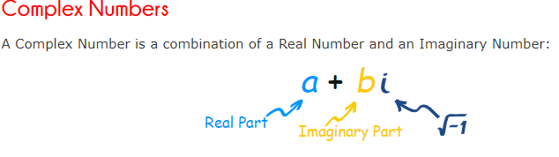



In our course, we will learn about manipulation and solving equations beyond real solutions. We will use the algebraic methods in manipulation and solving problems.

Example

The equation of a circle in real number system is but in complex number system it is .

Before we look at complex number problems let’s study about roots.



Surds (Roots)

Surds are such expressions as which cannot be evaluated exactly. They are irrational.

Expressions involving surds is simplified. The following rules apply:

2. (like surds can be added or subtracted)

Note

1. for non-zero and



*To simplify a surd like square roots we have to write the number inside the surd as product of two factors, one factor has to be a* ***largest square number*** *of that surd.*

Eg

Example 1

Simplify each of the following:

1. e.
2. f.
3. g.

***When fractions are involved with surds, it is the normal practice to eliminate the surds from the denominator; this called rationalising the denominator (ie. clearing it of irrational numbers.)***

For expression of the type , we multiply the top and the bottom by giving

Where and are numbers

Examples

Simplify



**Conjugate surds**

**Conjugate surds** are surds, which will differ in sign

**Note**

The rule only applies to binomial (two terms) expressions

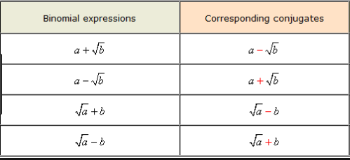

Example: Write down the conjugate surds of the following

**Simplifying binomial surds written as fraction**

Consider

we multiply the top and the bottom by , called the conjugate.

Example 1

Simplify the following,

a. b. c. d. e.



Example2: Write in form.

Example 3: If and , find in simplified form.

**Menu For the day**

Solve the given equation for in terms of

Review

1. If calculate the values of and.
2. If calculate the values of and.

**Assignment One**

1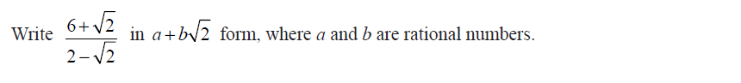

2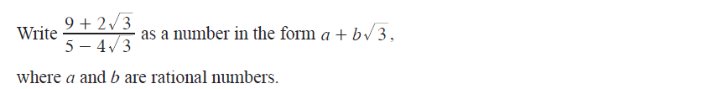

3 

4 



5 

6 

7 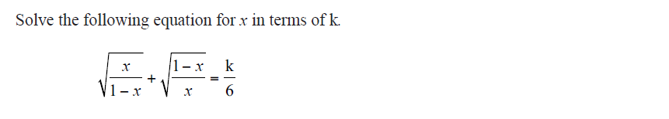

8 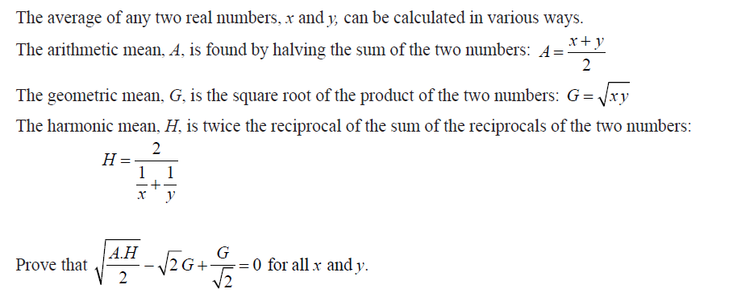



**Applying surds to complex number**

Under real number system square roots of negative numbers does not exist. But in complex number system it is possible to find square roots of negative numbers by doing the following substitution.

or

Note constructively stands for imaginary (see above).

Simplify

A complex number is made of real and imaginary numbers. We represent the set of complex numbers by letter C. The letter represent arbitrary complex number. Any complex number is written as or or .

We call, the real part of written as . We call the imaginary part of written as .

**Note**: That does not include it is just the coefficient of

**Examples**

1. Simplify
2. b. c d
3. Simplify these numbers and classify them as real, imaginary or complex numbers.
4. b c
5. Find Re(z) and Im(z) for the given complex numbers.
6. b c



**Adding and Subtracting Complex Numbers**

In adding or subtracting two or more complex numbers, ADD the real parts and ADD the imaginary parts of the complex numbers.

Example: If and

Find

**Complex conjugate**

Every complex number has a conjugate number denoted as . If then its conjugate .

Write down the conjugate of these numbers.



**Multiplying Complex Numbers**

Expand (multiply) the brackets and write the answer in the form

1. Calculate
2. Given Calculate.
3. If , show that

**Dividing Complex Numbers**

Multiply the numerator and denominator of the fraction by the conjugate of the denominator. Write your final answer in the form**.**



(Refer to simplifying surds in fraction form)

Calculate the following:

1. d.
2. e.

2 If and , find

**Example: write in the form. State and values.**

**Complex numbers are plotted on an Argand Diagram**

Part A- writing complex numbers given the argand diagram

Part B Plotting complex numbers on an Argand diagram

1. Plot the following on an Argand diagram.

a. b. c. d.

2. If and . Plot the following on the Argand diagram.

a.

b.

c.

d.

3.

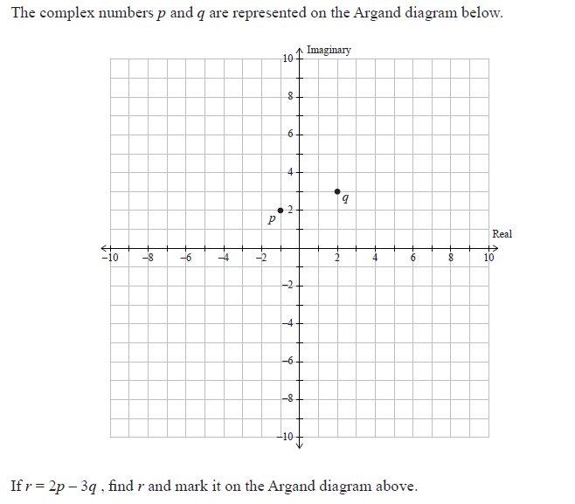

If , find and mark it on the Argand diagram above.



**Quadratics**

Manipulation

1. Expanding brackets
2. Factorising- especially difference of square.

Revise year 12 work

* Quadratic formula
* Discriminants

**Completing the square**

It means that you write the quadratic expression; in the form where and are numbers.

For example, in the expansion of.

Notice that the last term, is the square of half the coefficient of,.

Method

1. See that the coefficient of is 1 always, if it is not 1 then adjust the coefficient to 1.
2. Add a box squared to and subtract a box squared from
3. Divide the coefficient of by 2 always, the answer will go in the square boxes.
4. Rewrite the expression as

**Example:**

Complete the square on

Answer

Complete the square on the following



**Solving Equations**

1. **Quadratic Equations**

A quadratic equation can be solved either by completing the square or by factorising or by using the quadratic formula.

1. **Solve by completing the square.**
2. If express in terms of and
3. For any quadratic equation in the form . Show that .

Answers

i).

ii)

iii)

iv) was done in class

1. **Solve by using quadratic formula or by factorising.**

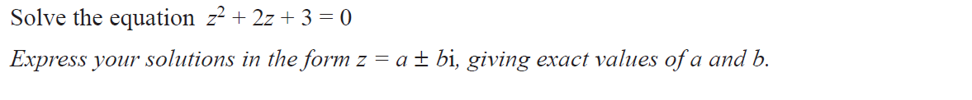

2. If one root of is twice the other show that

Answers

i).

ii)

iii)

iv)

v) use the idea of sum and product of roots (year12). Let and be the two roots then

(sum of roots)

(product of roots)

So replace the

Make the subject in the first equation and replace into the second equation, rearrange to the required form.



**DISCRIMINANT**

The discriminant of a quadratic equation is:. The root of any quadratic equation depends on the discriminant value.

For one real root the discriminant is 0

For two real roots the discriminant is greater than 0 (i.e. .

For no root the discriminant is less than 0 (i.e..



Example:

1. Find one value of for which has real roots.

Answer

1. If the equation has real roots show that

Answer

Set the equation using discriminant rule

**Re-arranging**

Re-arranging formula or rule means we write a given letter in terms of another letter with numbers (.i.e. solve the equation for the unknown).

Example:

1. Write in terms of
2. For the given rule write as the subject.
3. If prove that.
4. If prove that, .



**Applying the idea of solving Equations to complex number**

Basic Skills

Methods

* The idea is to rearrange the equation with unknowns on one side and number parts on the other side.
* Equate the real parts of both sides and imaginary parts of both sides, of the equation.
* Solve for the unknowns

Examples

(rearrange)

(real parts)

(imaginary parts—remember do not include i)

Replace for y in the real part equation and solve for x

(square both sides)

(remember

(real part)

(imaginary part)

1. Find the real numbers and which satisfy these equations:

Answers

1. If find and

(note you may end with a quadratic equation of different form. Example to solve the equation --- use the idea learned in year 12. Let

(not possible to solve)

(answer)

OR solve otherwise.

Answer

1. If and . Solve for and given that

Answer

1. Given . Solve for

Answer

**Quadratic Equations**

For quadratic equation either factorise or use quadratic formula or complete the square to solve the equation.

(Refer to real number).

Example A: Solve the following using the quadratic formula;

Answers

Example B: Solve by completing the square;

and plot the roots on an Argand diagram.

Answer

You can plot the above

Example C:

Solve the equation

Write your answer in the form , where *a*, *b*, and *c* are integers.

Answer

Answer

DO ASSIGNMENT 2 and email me for marking.



Assignment 2

1 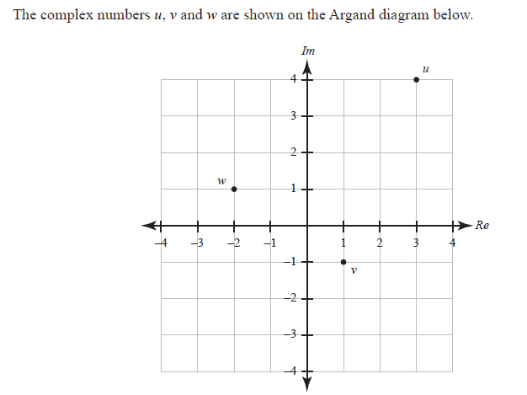

1. If find and mark it on the Argand diagram.
2. If

2 



3 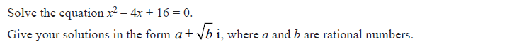

4 

5 



**Polynomials**

Dividing Algebraic Fractions

Recap: form of a fraction

In product form:

In long division form:

Example:

Method for Long division

1. Arrange the divisor and the dividend in descending powers of
2. Each term of the quotient is obtained by dividing the first term of the divisor into the first term of the new dividend.
3. After each division, the next step is to subtract and bring down the next term.
4. The process is repeated until the remainder is of a lower power than the divisor.

*Note:*

1. *If there are any consecutive powers of missing, these should be included by using 0 as their coefficient.*
2. *All terms of the same power are kept in the same vertical column.*



Example 1:

Divide by

Example 2:

Divide by

Example 3:

Divide by

Example 4:

Express in the form, , determine the values of and .

*Answers*



**Remainder Theorem**

If the function a polynomial in, is divided by until the remainder does not contain **OR** solve for in terms of substitute into the expression, then the remainder is equal to.

Example

1. Find the remainder when is divided by .
2. Find if the remainder is 5 when is divided by
3. If and gives same remainder when divided by solve for in terms of



**Factor Theorem**

As a direct deduction from the remainder theorem, we can say that for a polynomial if then is a factor of

This result is known as the factor theorem and can be used to factorise a polynomial.

Example

Factorise the expression.

Let.

By trial and error method choose values which give the remainder zero.

= 6

is not a factor

= 0

is a factor

Other factors can either be found by further use of the factor theorem or by long division.

Using long division, the other factors are

-----------------------

---------------------

------------------

0

Hence

(Further factorise)

1. Factorise the following
2. If is a factor of. Find the value of
3. The remainder obtained when is divided by is equal to the remainder obtained when the same expression is divided by. Find the value of
4. If and are factors Solve for and.

**You are a Legend**

If and have a common factor of where and are real.

Show that:

Answers

**Remainder Theorem**

1. 17

**Factor Theorem**

1a.

1b.

Legend

**Exercise**:  **Remainder and Factor Theorem**

**Remainder Theorem**

1 Find the remainder when

1. is divided by
2. is divided by
3. is divided by
4. is divided by

2 Find if the remainder is 4 when is divided by .

3 Find if the remainder is -10 when is divided by

4 Find if the remainder is 6 when is divided by

5 The expression has a remainder of when divided by . Solve for in terms of

6 If and . Find .

7 The expression is divisible by but leaves a remainder of when divided by Find the values of and

**Factor Theorem**

1 Factorise the following

2 Find if 3 has a factor of .

3 Given that is a factor of find the remainder when the

expression is divided by .

4 If find the values of and

5 If and have a common factor of , show

***Answers***

Remainder Theorem

1

2

3

4

5

6

7

*Factor Theorem*

1

2

3

4

5

**Relationships between roots and coefficients**

If and are the roots of the quadratic equation

, then and.

Proof:

Equate the coefficients on both sides

(Coefficient of)

(Constant terms)

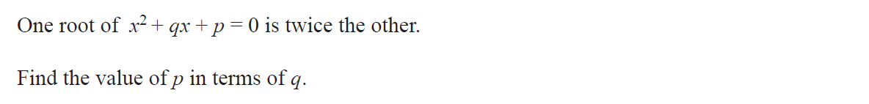

Suppose that and are the roots of a cubic equation of the type. By factor theorem, since is a root of the cubic equation must be a factor and, in a similar way, so must and.

Thus

By expanding these brackets and comparing the result with, the following results are obtained. , and.

*Prove the above for your homework*

Example 1

If and are the three roots of the cubic equation .

Find the value of;

Example 2

If and are the three roots of the cubic equation, Prove that;

**Manipulating Complex Numbers**

1. Factorise
2. The two roots of a quadratic equation is

, find the equation.

1. Show that and are both factors of determine the other factor.

**Exercise**

1. Give the equations with these roots:
2. Show using factor theorem, that the linear expressions below are factors of given polynomial and determine the other factor(s).

**The Conjugate root theorem**

The complex roots of any polynomial over the real numbers come in conjugate pairs.

If is a complex root, then is the other root.

**Solving Polynomial Equations**

1. Solve:
2. Given that is a root of the polynomial equation . Find the other roots.
3. Given that is one of the complex roots of the cubic equation Find the value of the real number and the other roots.
4. is one of the roots of the polynomial equation . Find the value of A.
5. One solution of the equation is If is a real number, find the value of and the other two solutions of the equation.

**KNOCK X 2 WHOSE THERE!**

1. Form a polynomial equation of degree 4 with complex roots and The coefficients of the polynomial are real.
2. One root of the polynomial equation is . Solve for and find the other roots.

**Assignment 3**

1.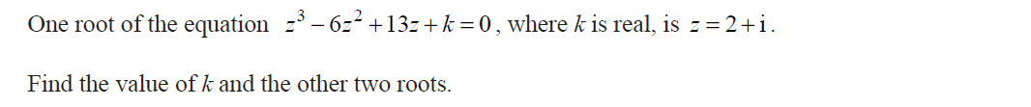

2. 

3. 

4. 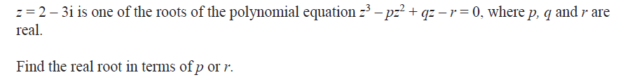

5. 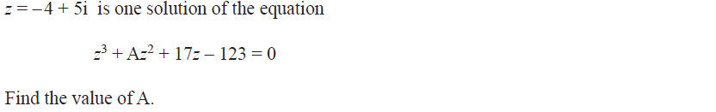

6. 

7. 

8. 

9. If and are the four roots of the Quartic equation,. Find the value of:

*Answers*

1. and

1. and
2. or
3. and
4. simplify as required
5. and (form two equations and solve simultaneously)

**MORE EQUATIONS**

**Solving Cubic Equations**

To solve a cubic equation or a higher degree equation, we must first find one of its factor, using factor theorem (refer to factorising polynomials).

Example

1. Solve the following equations.
2. Given
3. If is a rational solution of , find the other two solutions in simplified surd form.
4. Write in factorised form.

**Fraction Equation (Partial Fractions)**

Example

Solve for the given constants

Example

Solve

Solve

Exercise

Solve

**Equations with Powers or Surds or Absolute values**

1. Power Equations

In short has two real solutions provided

has one real solution.

Solve the following

1. Surd Equations

Equations with surds are solved by squaring each side. You could end up with false solutions. Always check your solution by substituting back into the equation.

Solve the following:

1. Absolute value equations

Equations with absolute value are solved by squaring.

Solve

Solve

**Equations with Logs or Exponents**

Log equations

Equations with logs are solved by using the definition and log rules. Always check your solutions. (Note is defined for positive only), is defined for positive and negative

Example: Solve the following equations:

**Answers**

1. 245
2. 4.5
3. 2
4. 8.39
5. 1
6. 5.74 and -1.74

***Answer***

change to same base

Hence

or

viii)

*Answer*

64

**Assignment**

Solve the equation for x and y.

4

Answer

note

Let and

Solve the two equations simultaneously for a and b

and

Hence

Exponential Equations

In an exponential equation, the variable to be solved is in the exponent (power). Exponential equations are solved by taking *logs on both sides.* Use either log or, and then apply log rules.

Examples: Solve the following equations,

*Answers*

1. 4
2. -2.13
3. -0.2
4. 0.488
5. 1.32
6. 2
7. 2.16

**Homework**

Solve for x

or

Equations with constants

Exercise

1. Solve, expressing in terms of .
2. Solve for in terms of
3. For what values of does the equation have two real solutions?
4. Solve in terms of

**Assignment 4 (email Questions 3,4,6,7,17 for marking)**

1

2

3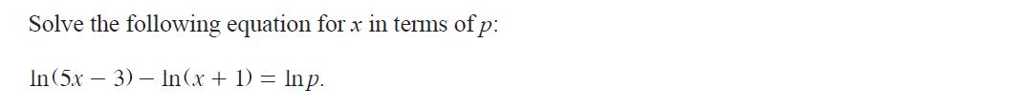

4

5

6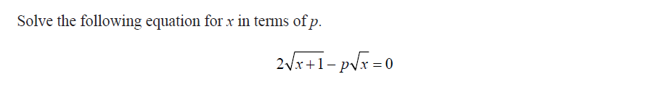

7

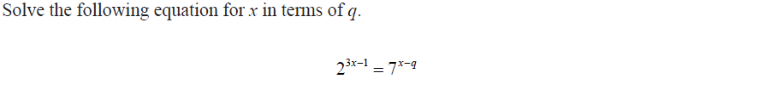

8

9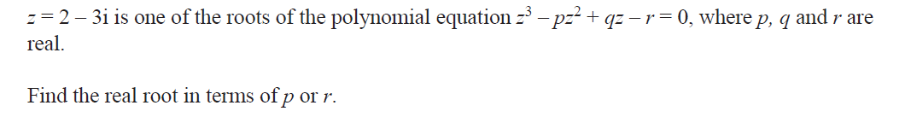

10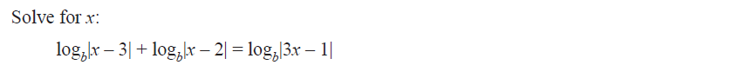

11

12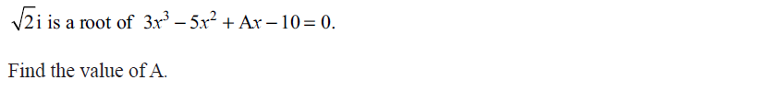

13

14

15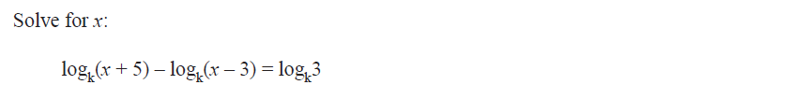

16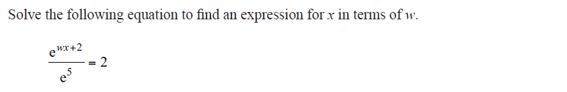

17

***Answers***

1. and the third root is

**Modulus and Argument of Complex Number**

The complex number is represented in an Argand diagram.

The **modulus** of notation, or mod(z) is the length of

The **argument** of notation, is the angle between the positive x – axis and

and , the angle is measured in **radians**: **.**

and for arg(z) use SOH, CAH, or TOA.

***Note:*** *If z is purely real, then the modulus of z is the same as the absolute value of z.*

**Example:**

1. If find and .
2. If and .
3. Is
4. Is
5. Is

***Answers***

1. and or
2. i)

ii) Yes

iii) or

iv) not the same

**Notations for Complex Number**

The **rectangular form**:

The **polar form**: or

**Graphing complex number given in polar form**

Graph the following on an argand diagram:

1. b.

**Conversions**

1. **Polar to rectangular**

Write the following in form:

1. ii. iii.

***Answers***

2. **Rectangular to polar**

Write the following in polar form:

1. ii. iii.

iv

***Answers***

i).

ii).

iii).

iv).

**Multiplication of complex numbers in polar form**

When **two** complex numbers are written in polar form their product is found with the Rule:

**Example**

If and find:

1. in rectangular form
2. in polar form
3. in rectangular form and polar form

Note -z=-1xz (convert -1 into polar form for c and multiply to z)

***Answers***

**Division of complex numbers in polar form**

When **two** complex numbers are written in polar form their quotient (division) is found with the rule:

**Example 1**

If and , find:

1. in polar form and rectangular form.
2. in polar form.

**Example 2:** Find:

1. in rectangular form.
2. in polar form and rectangular form.
3. The complex has modulus of 5 and argument of radians. Plot on an argand diagram.

***Answers***

1 a.

b.

2 a .

b .

c. Convert the number into rectangular form and plot.

**De Moivre’s Theorem**

De Moivre’s theorem provides a method of raising complex numbers to integer powers. The theorem applies to complex numbers that are written in polar form.

**De Moivre’s Theorem**

for

Example: Calculate in rectangular form.

**Note**

In fact, De Moivre’s rule also works for (rational numbers). This means we can calculate .

Example2: Calculate, leave your answer in polar form.

Example 3: Calculate, leave your answer in rectangular form.

Homework

1. Calculate; leave your answer in polar form.
2. where is a constant
3. Calculate; leave your answer in rectangular form.

**Roots of Complex Numbers**

Equations of the form (where can be a real or imaginary or complex number) will have solutions. We use De Moivre’s theorem to find these solutions.

**Method**: (Mr Lal’s Method)

To solve the equation given as

1. Write in polar form as
2. Apply De Moivre’s theorem to get the first root.
3. Workout the consecutive root, divide by the power ().
4. Keep adding the consecutive roots to the previous root till you get all the roots.

Example: Solve the given equation and leave your answer in polar form.

1. where
2. where

**Other Method:** To solve the equation given as

1. Write in polar form as
2. Write more generally as
3. Apply De Moivre’s theorem to get
4. Substitute, in turn, consecutive integer values for . Check that these give complex numbers with argument between (radians).

**Note**

Take value around zero and including zero.

Example: Solve the following equations and leave your answer in polar form.

1. (

Example 2: Plot the answers to b, c and e on an argand diagram.

Review ***Survival of the fittest***

**Station A**

1. Find each of the roots of the equation
2. Let be the root in part (a) with smallest positive argument. Show that the roots in part (a) can be written as

**Station B**

1. Solve the equation and leave your answer in polar form.
2. Solve the equation and leave your answer in Cartesian form.



**Locus**

*Locus means path or position. The locus may be shown by sketch or by giving the equations of lines or curves.*

**Sketching locus**

Example; Sketch the locus of the complex number *z* satisfying the condition



**Locus Equation**

Examples:

1. Find the equation of the point representing z if
2. Find the locus of the point representing z if is purely imaginary.
3. 

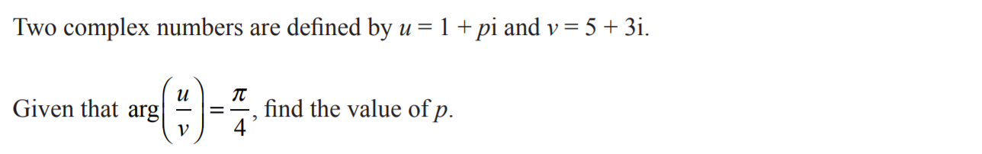

Let’s eat out at Mr Lal’s restaurant the Calculus Chef

MENU of THE day

**Entree**

Argument SOUP with Complex ingredients.

1. Write  in *a* + *bi* form where *a* and *b* are real.
2. is a root of . Both and are real. Find the values of *a* and *b.*

**Mains**

1. Sketch the locus defined by the equation
2. Determine the Cartesian equation of the locus defined by
3. Find the equation of the locus representing

**Dessert**

Find the value of *b* if and .

**I HOPE YOU HAVE ENJOYED YOUR MEALS**

**Proofs**

1. Show if then:
2. Show that
3. Show that, represents the equation of a circle.
4. Find the value of and when
5. *u* and *v* are two complex numbers, *v* ≠ 0, such that .

Prove that is purely imaginary.

1. Find the values of the complex number *u* and *v* in the form given:

and

1. Given and , find an expression for in terms of